PizzaDronz: Test Results and Coverage Evaluation
1. Overview
This document presents the results of testing carried out for the PizzaDronz system, as specified in the accompanying Requirements Specification and Test Plan documents. It provides evidence of the testing techniques applied, the evaluation criteria used to assess adequacy and an interpretation of test outcomes including code coverage results. This document is referenced by the portfolio and is not subject to the page limit.

2. Implemented Testing Techniques
Testing was conducted primarily using automated tests written with JUnit 5 and executed via Maven Surefire, supported by Mockito for isolating external REST dependencies. The following testing techniques were applied:
- Unit testing of deterministic logic, including price calculation, credit card validation, expiry date validation, CVV validation, coordinate validation and distance calculation.
- Controller-level testing of REST endpoints (validateOrder, calcDeliveryPath) to verify correct HTTP behaviour and validation outcomes without deploying the full system.
- Negative and boundary testing, focusing on invalid inputs such as malformed credit card details, incorrect totals, excessive pizza counts, undefined pizzas and empty orders.
- Mocked integration testing, where calls to external restaurant and airspace REST services were replaced with stubs to allow controlled testing of both normal and failure scenarios.
- Context loading test, verifying that the Spring Boot application context starts correctly.
Manual exploratory testing using Postman was used earlier in development to validate endpoint behaviour and JSON responses. This informed test case design but is not relied upon for regression testing.

3. Test Execution Summary
Automated tests were executed using the command:
mvn clean test
Test Results Summary
- Total tests executed: 19
- Failures: 0
- Errors: 0
- Skipped tests: 0
- Build status: SUCCESS
This confirms that all implemented automated tests pass consistently in a clean environment.
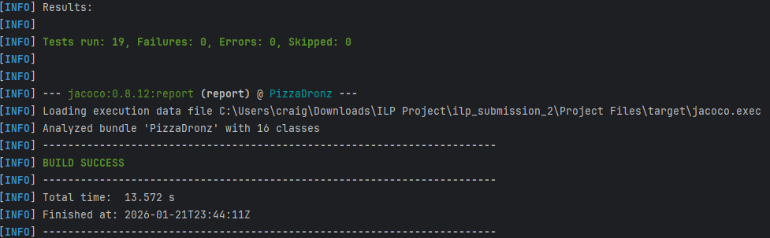
Figure 1: Maven test execution output showing 19 tests executed with zero failures.

4. Coverage Measurement and Evaluation Criteria
Code coverage was measured using JaCoCo during test execution. The evaluation criteria used were:
- Instruction coverage: used as an indicator of how much executable logic was exercised.
- Branch coverage: used to assess coverage of conditional logic, particularly in validation routines.
- Coverage interpreted qualitatively, rather than against a fixed numeric target, due to the presence of complex geometric logic and defensive code paths.
Coverage was analysed at both package and class level, with particular focus on the controller where most validation logic resides.

5. Coverage Results
Overall Coverage
- Instruction coverage: 33%
- Branch coverage: 28%
Coverage is uneven across the codebase, reflecting deliberate prioritisation rather than insufficient testing.
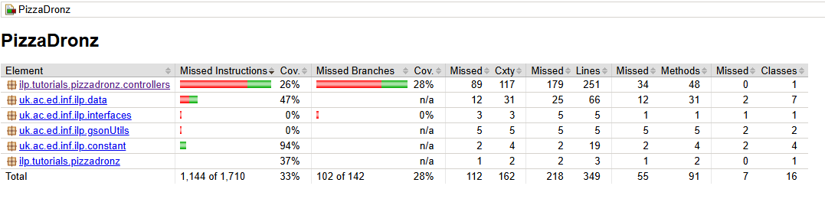
Figure 2: JaCoCo package-level coverage report showing overall instruction and branch coverage.
Controller-Level Coverage
The PizzaDronzController shows:
- High coverage (near or at 100%) for:
  - validateOrderLogic
  - validateRestaurants
  - validateExpiryDate
  - validateCoordinates
  - calculateDistance
  - calcDeliveryPath (core validation and path initiation logic)
- Low or zero coverage for:
  - Geometric helper methods related to polygon processing and path optimisation
  - Parsing utilities not exercised directly by controller tests
This reflects the testing focus on functional correctness and robustness, rather than exhaustive geometric validation.
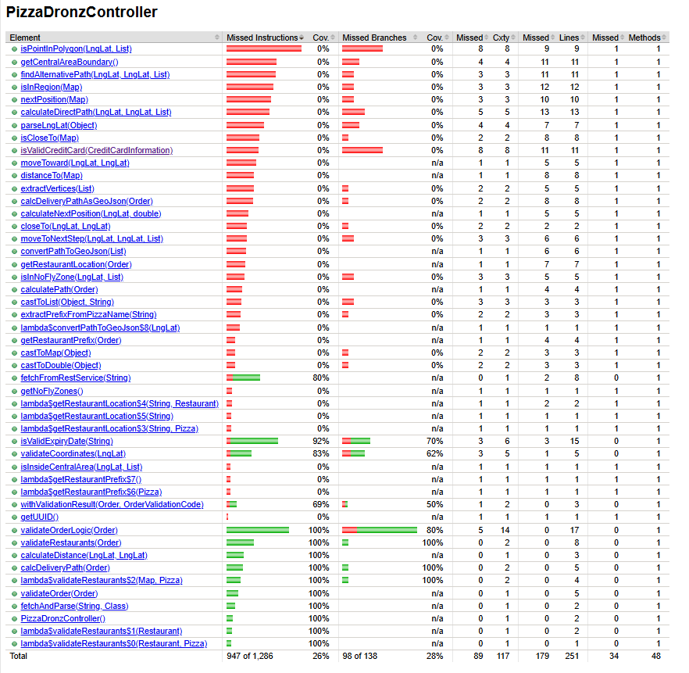
Figure 3: JaCoCo method-level coverage report for PizzaDronzController.

6. Interpretation of Results
The test results demonstrate strong assurance for all core functional requirements:
- All order validation rules (FR-1 to FR-9) are exercised through positive, negative and boundary cases.
- Delivery path computation is verified for valid orders without relying on live external services.
- Failure modes for invalid orders and missing data are consistently handled and tested.
Lower coverage in geometric path-planning helpers is acknowledged as a limitation. These methods are algorithmically complex, deterministic and indirectly exercised through higher-level tests. Full path correctness testing would require detailed geometric oracle construction, which was beyond the scope of the coursework and was therefore deprioritised in favour of validation correctness.

7. Yield and Adequacy Assessment
Test yield is high relative to the objectives of the system:
- Validation faults are detected early and localised precisely.
- Tests fail deterministically when logic is altered incorrectly.
- The absence of failures across repeated executions indicates stable and repeatable testing.
While coverage metrics are moderate numerically, they are adequate and justified given the testing goals and system constraints. The results provide strong confidence that the implemented requirements are met.

8. Summary
Testing of PizzaDronz successfully applied a range of automated testing techniques supported by coverage measurement. The results show full correctness for validation logic and robust handling of invalid inputs, with acknowledged and justified limitations in geometric path testing. This document provides the primary evidence for Learning Outcome 3 and supports the evaluation presented in the portfolio.

